Evaluation Report of the BMZ-Funded WASH & Climate Resilience Project in Kochogo South, Kisumu County: An OECD-DAC Criteria Assessment

DATAUPSKLL CONSULTING KENYA LIMITED
Project Evaluation Questionnaire Data Analysis Matrix
Project: BMZ-funded WASH & Climate Resilience Project
Implementing Agency: Habitat for Humanity Kenya (HFHK)
Location: Kochogo South, Kisumu County

INTRODUCTION
This report presents the evaluation of the BMZ-funded WASH & Climate Resilience Project implemented by Habitat for Humanity Kenya (HFHK) in Kochogo South, Kisumu County. The assessment was guided by the OECD-DAC criteria of Relevance, Effectiveness, Efficiency, Impact, and Sustainability, and is based on quantitative survey data, qualitative feedback, and participatory analysis from community members across the six villages.
The purpose of the evaluation is to determine the extent to which the project addressed community needs, achieved its intended outcomes, utilized resources effectively, and fostered lasting change. Insights drawn from the analysis provide evidence of achievements, highlight gaps, and identify opportunities for strengthening future programming.

- RELEVANCE
Evaluation Question: To what extent did the project address the most important needs and priorities of the community?

Key Findings
- Usefulness of interventions
An overwhelming 98.6% of respondents reported that project activities remain useful to their households and communities.
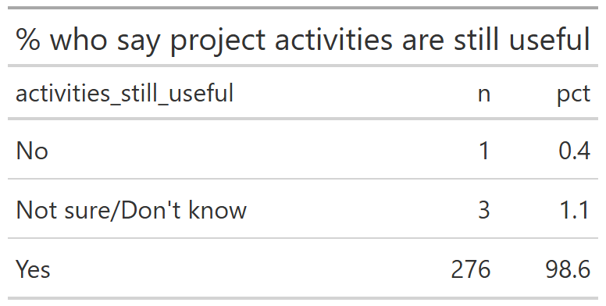
- Most useful interventions
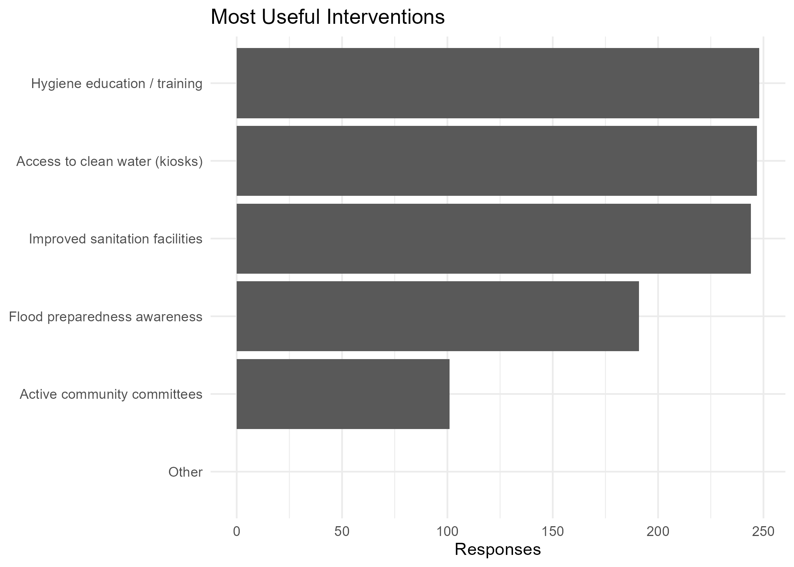
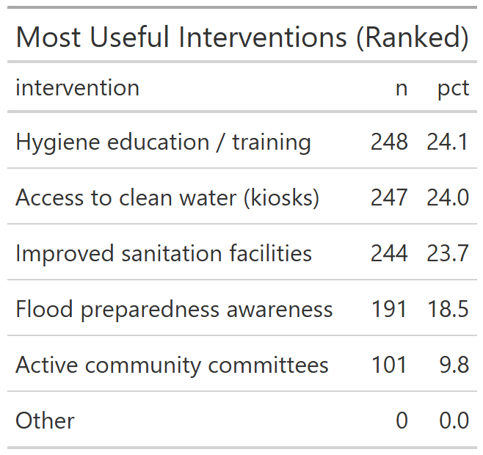
Ranked interventions showed that hygiene education/training (88.6%), access to clean water through kiosks (88.2%), and improved sanitation facilities (87.1%) were seen as most beneficial. Flood preparedness awareness (68.2%) and active community committees (36.1%) followed.
- Water access
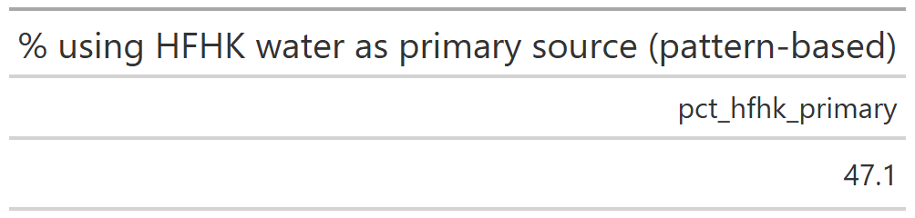
  - 47.1% currently use HFHK water systems as their primary source.
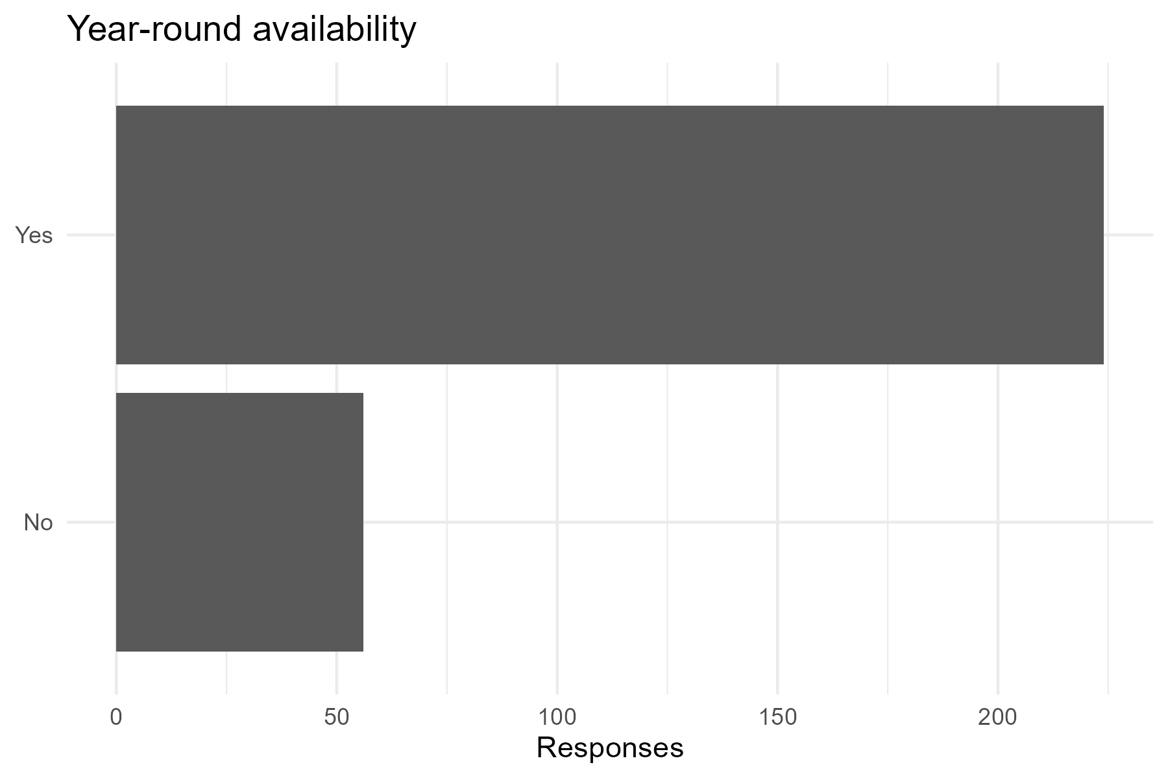
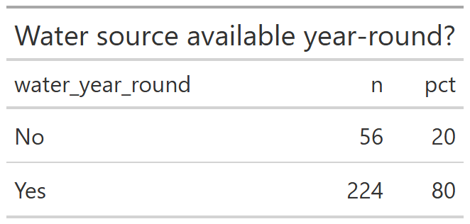
  - 80% reported year-round water availability.
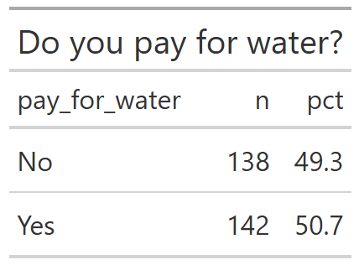
  - Half (50.7%) pay for water, and among them, 93.7% consider costs affordable.
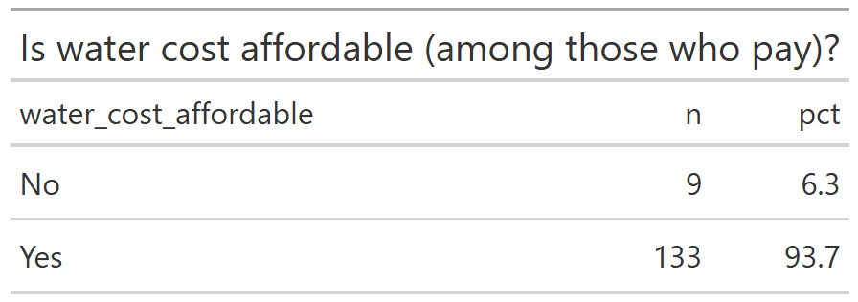

- Sanitation facilities
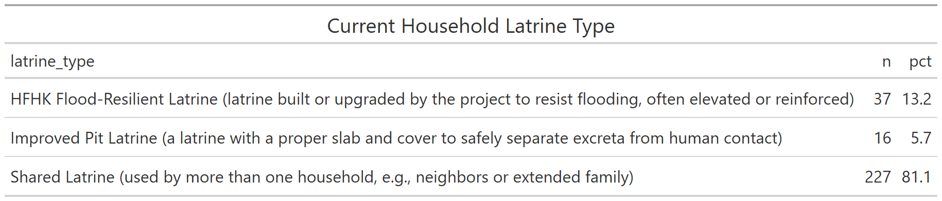
  - A majority (81.1%) rely on shared latrines, with only 13.2% using HFHK flood-resilient latrines.
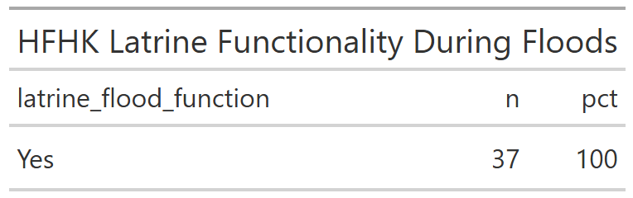
  - All HFHK latrines were reported functional during floods.
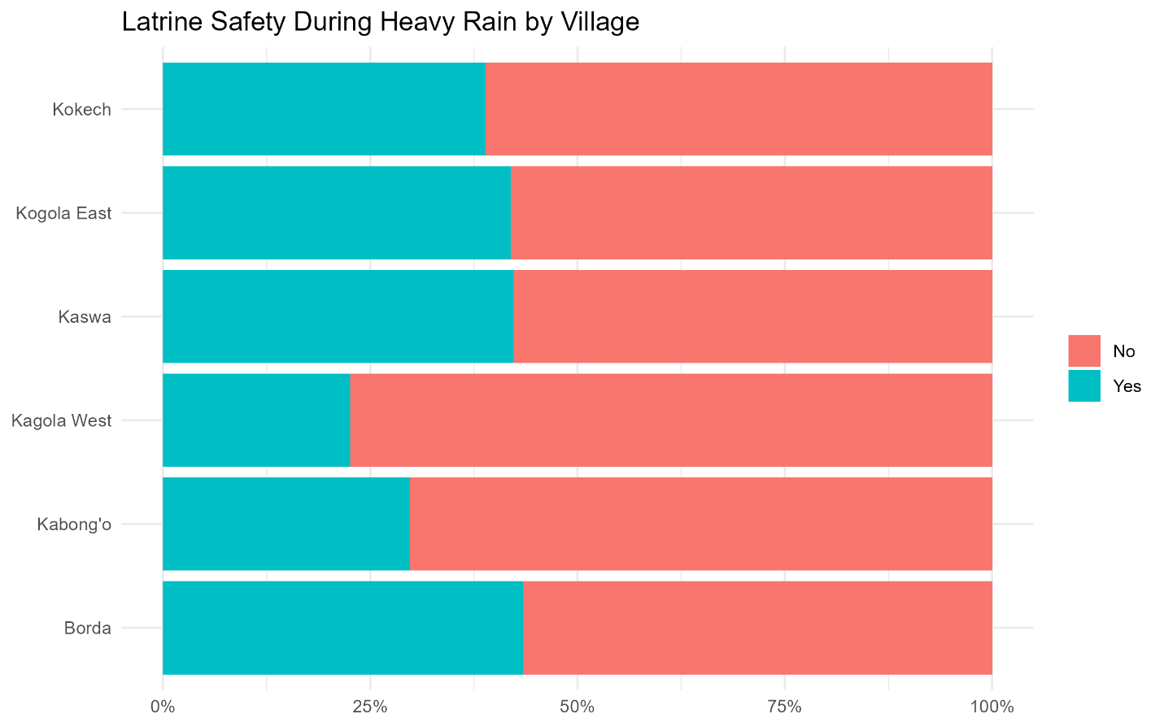
  - However, only 33.6% said latrines are safe during heavy rains, showing gaps in resilience.
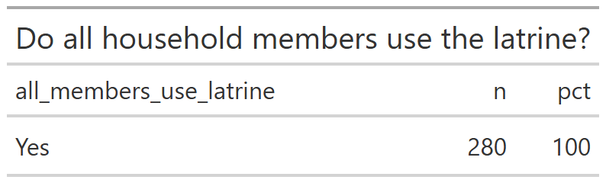
  - Importantly, 100% confirmed all household members use the latrine and satisfied
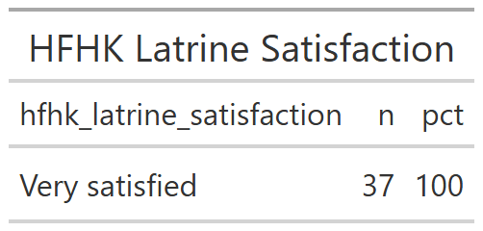

- Hygiene practices
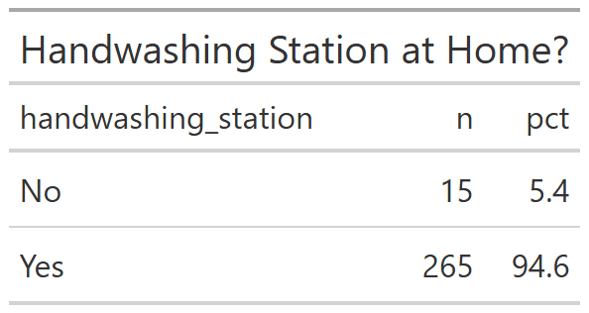
  - 94.6% households have a handwashing station, and nearly all (99.6%) had soap and water at the station.
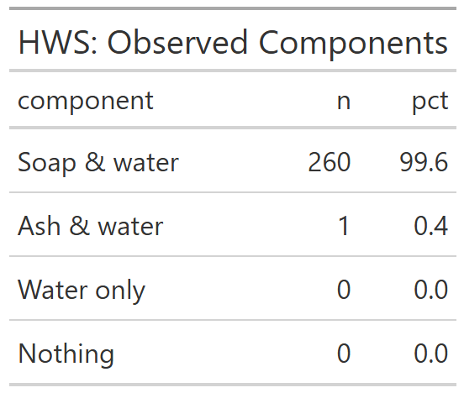
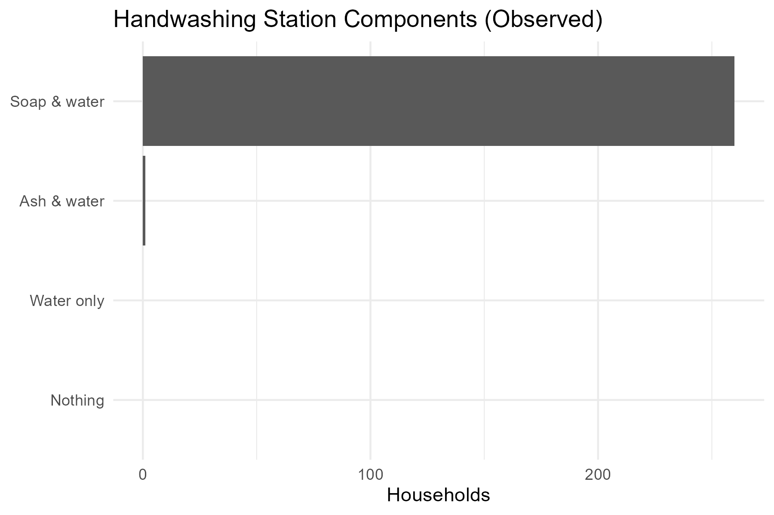
  - Self-reports indicate consistent handwashing at critical times.
- Climate resilience
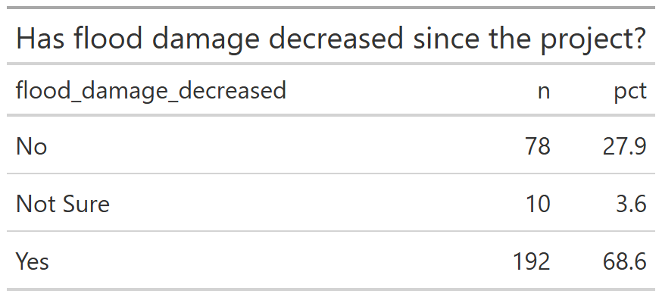
  - 68.6% said flood damage has decreased since the project.
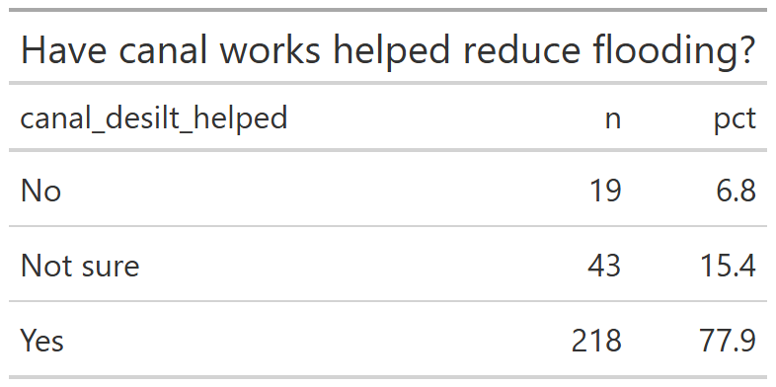
  - 77.9% confirmed canal desilting and related works reduced flooding in their area with Kokech Village toping the list.
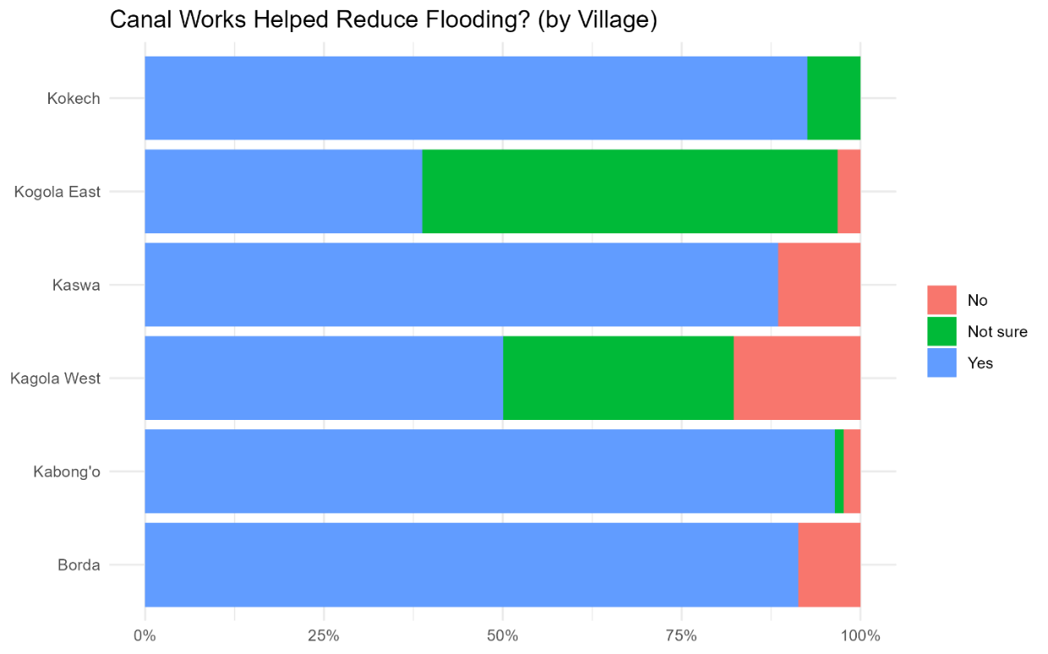
- Remaining challenges
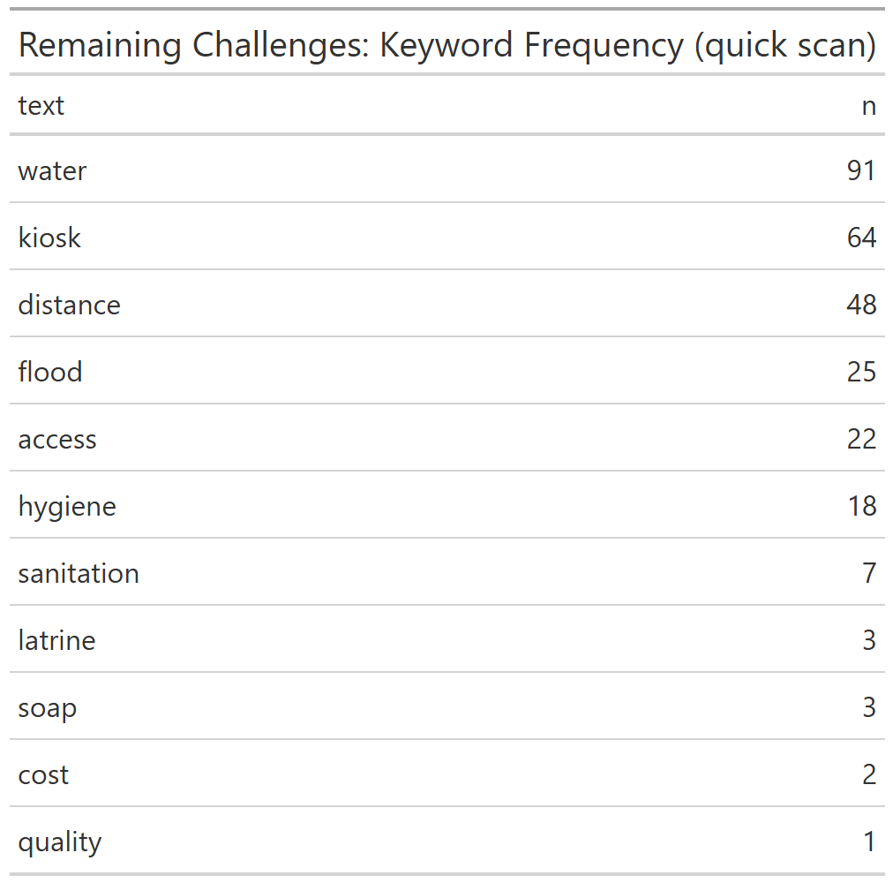
Open-text analysis highlighted issues with distance to kiosks, water availability, persistent flooding, and hygiene gaps. Water was the most frequently cited word (91 mentions), followed by kiosks (64) and distance (48).

Insights from Graphs/Plots
- Majority of Households are Female-Headed Across All Villages
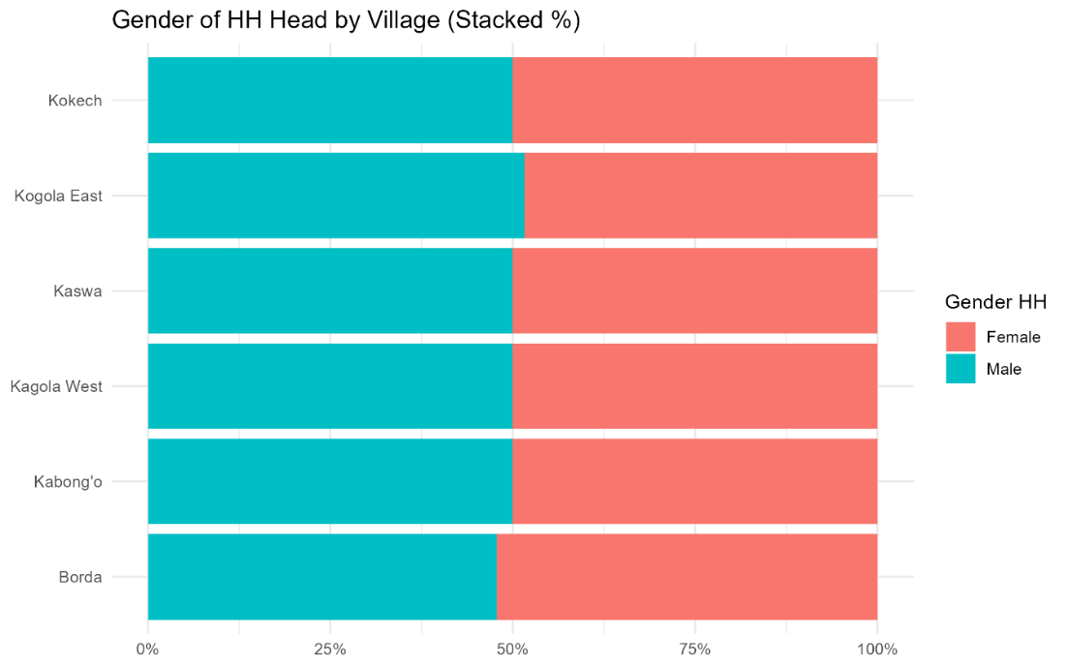
The stacked bar chart, titled "Gender of HH Head by Village (Stacked %)", provides insights into the gender distribution of household heads across six villages: Kokech, Kogola East, Kaswa, Kagola West, Kabong'o, and Borda. It reveals that in all villages, female-headed households outnumber male-headed households, with the percentage of female heads consistently higher than 50%. This finding is significant for development projects, as it indicates that a majority of the household decision-makers in this area are women. Consequently, for a project to be effective and relevant, its design and implementation should specifically consider the needs, priorities, and potential challenges of female household heads. The data suggests that a gender-sensitive approach, which empowers women and involves them in project planning and execution, would be highly effective.
- Bar charts of usefulness showed near-universal support for the interventions, with hygiene training and clean water access topping the list.

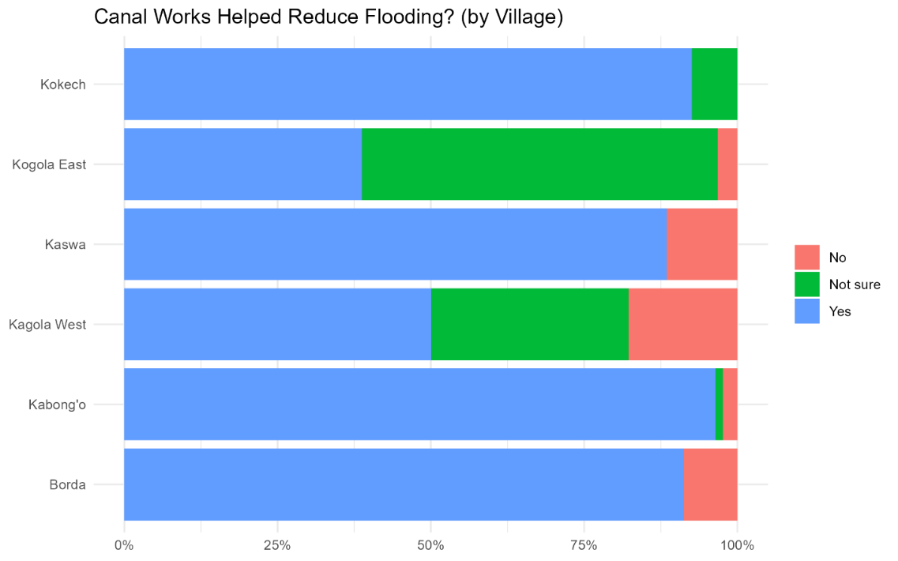
- Stacked plots of flood damage vs. canal desilting per village highlighted that most households reporting decreased flood damage were also in areas where desilting was effective, showing direct linkage.

- Keyword frequency/word cloud outputs reinforced that water and accessibility to kiosk remain top challenges, even after improvements.

Conclusion

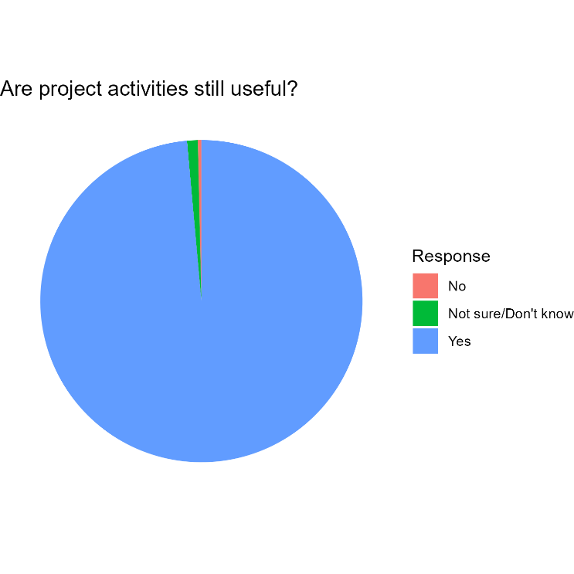
The project is highly relevant to community priorities. Nearly all respondents still find the interventions useful, particularly around water, sanitation, and hygiene training. With Kokech village 100% finding the activities still useful.
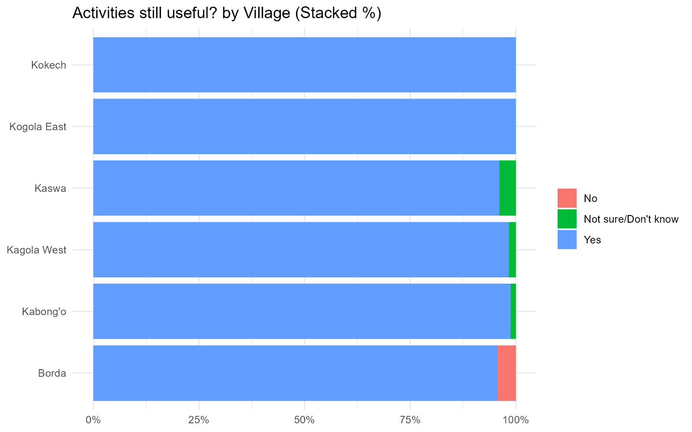

However, reliance on shared latrines and limited resilience of latrines in heavy rain indicate areas for improvement. Flood resilience interventions are largely successful, though distance to water points and remaining flood risks are persistent concerns. Overall, the project addressed core WASH needs but further strengthening of infrastructure resilience and equitable access would enhance long-term relevance.

- EFFECTIVENESS

Water access & time use
- Kiosk use is routine in most villages (e.g., Daily: Borda 69.6%, Kabong’o 58.3%), though some households report rare/never use (Kabong’o Never 23.8%).
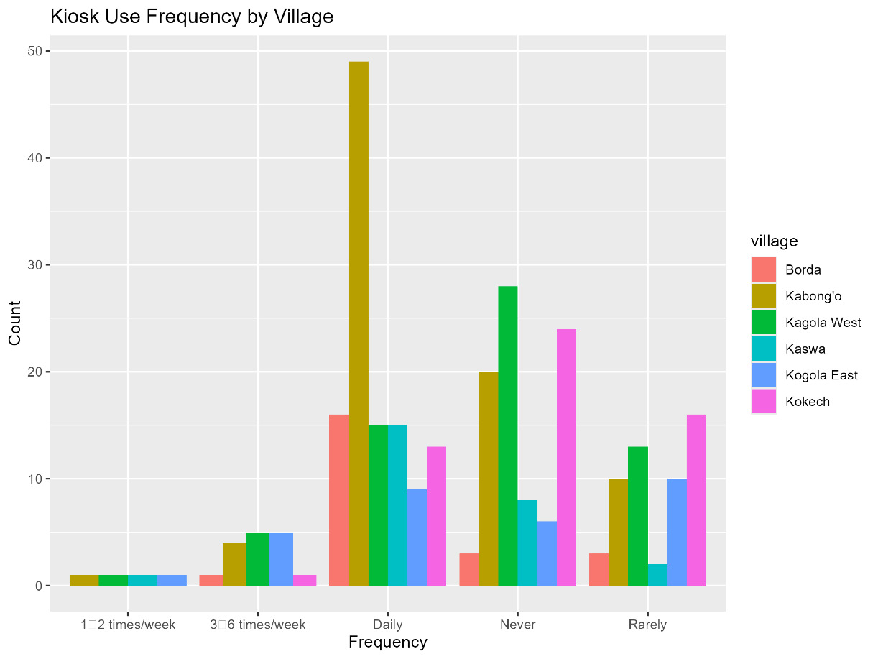
- Time to fetch water has improved for both genders: Female HH heads “Less time” 52.9%; Male HH heads 50.7% (about half for each).
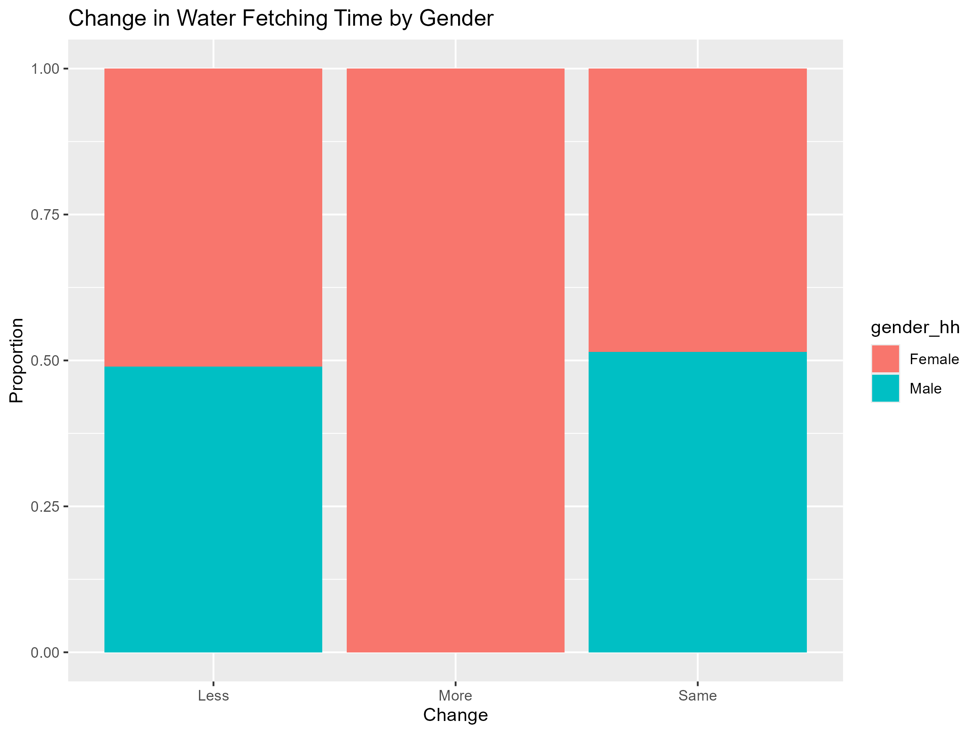
- Reported reasons (from notes) point to closer sources, shorter queues, and reduced cost.

Water quality & infrastructure reliability
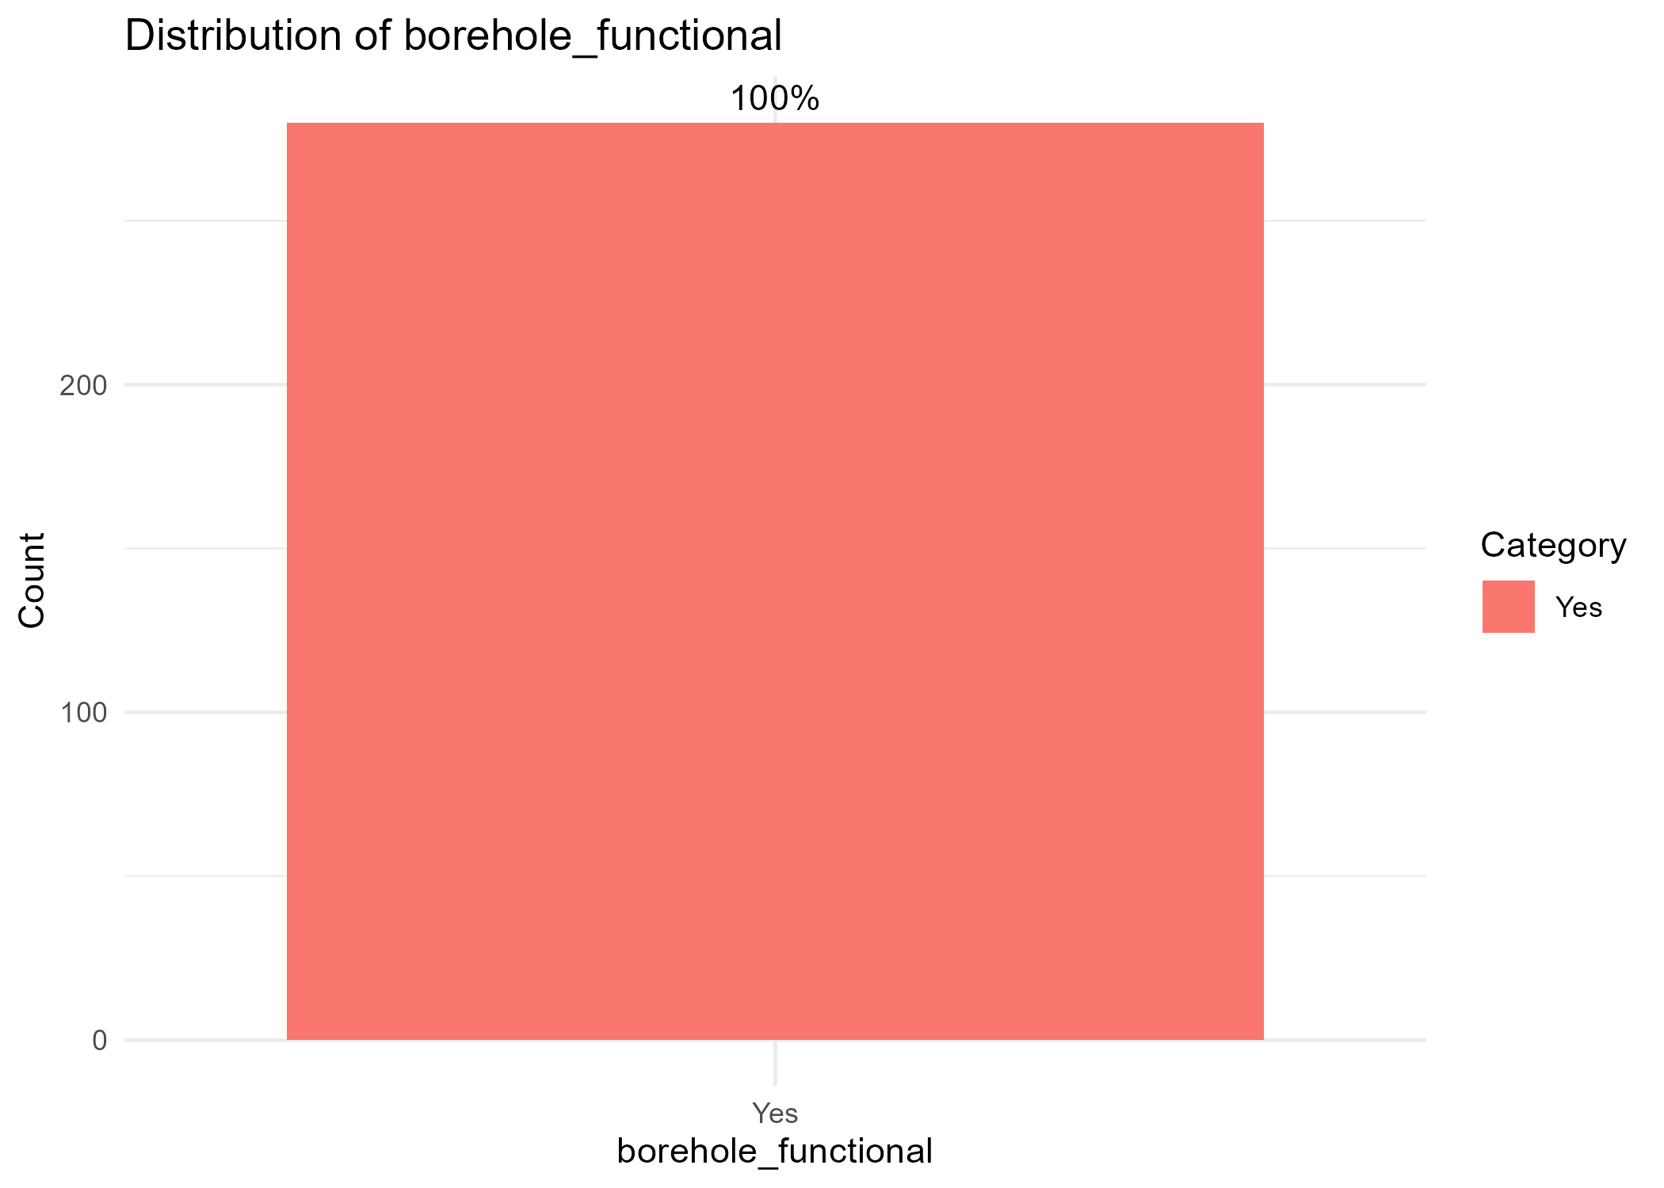
- Borehole functional in 100% of cases across all six villages (as reported), it was a Yes in all the respondents of the 6 villages.
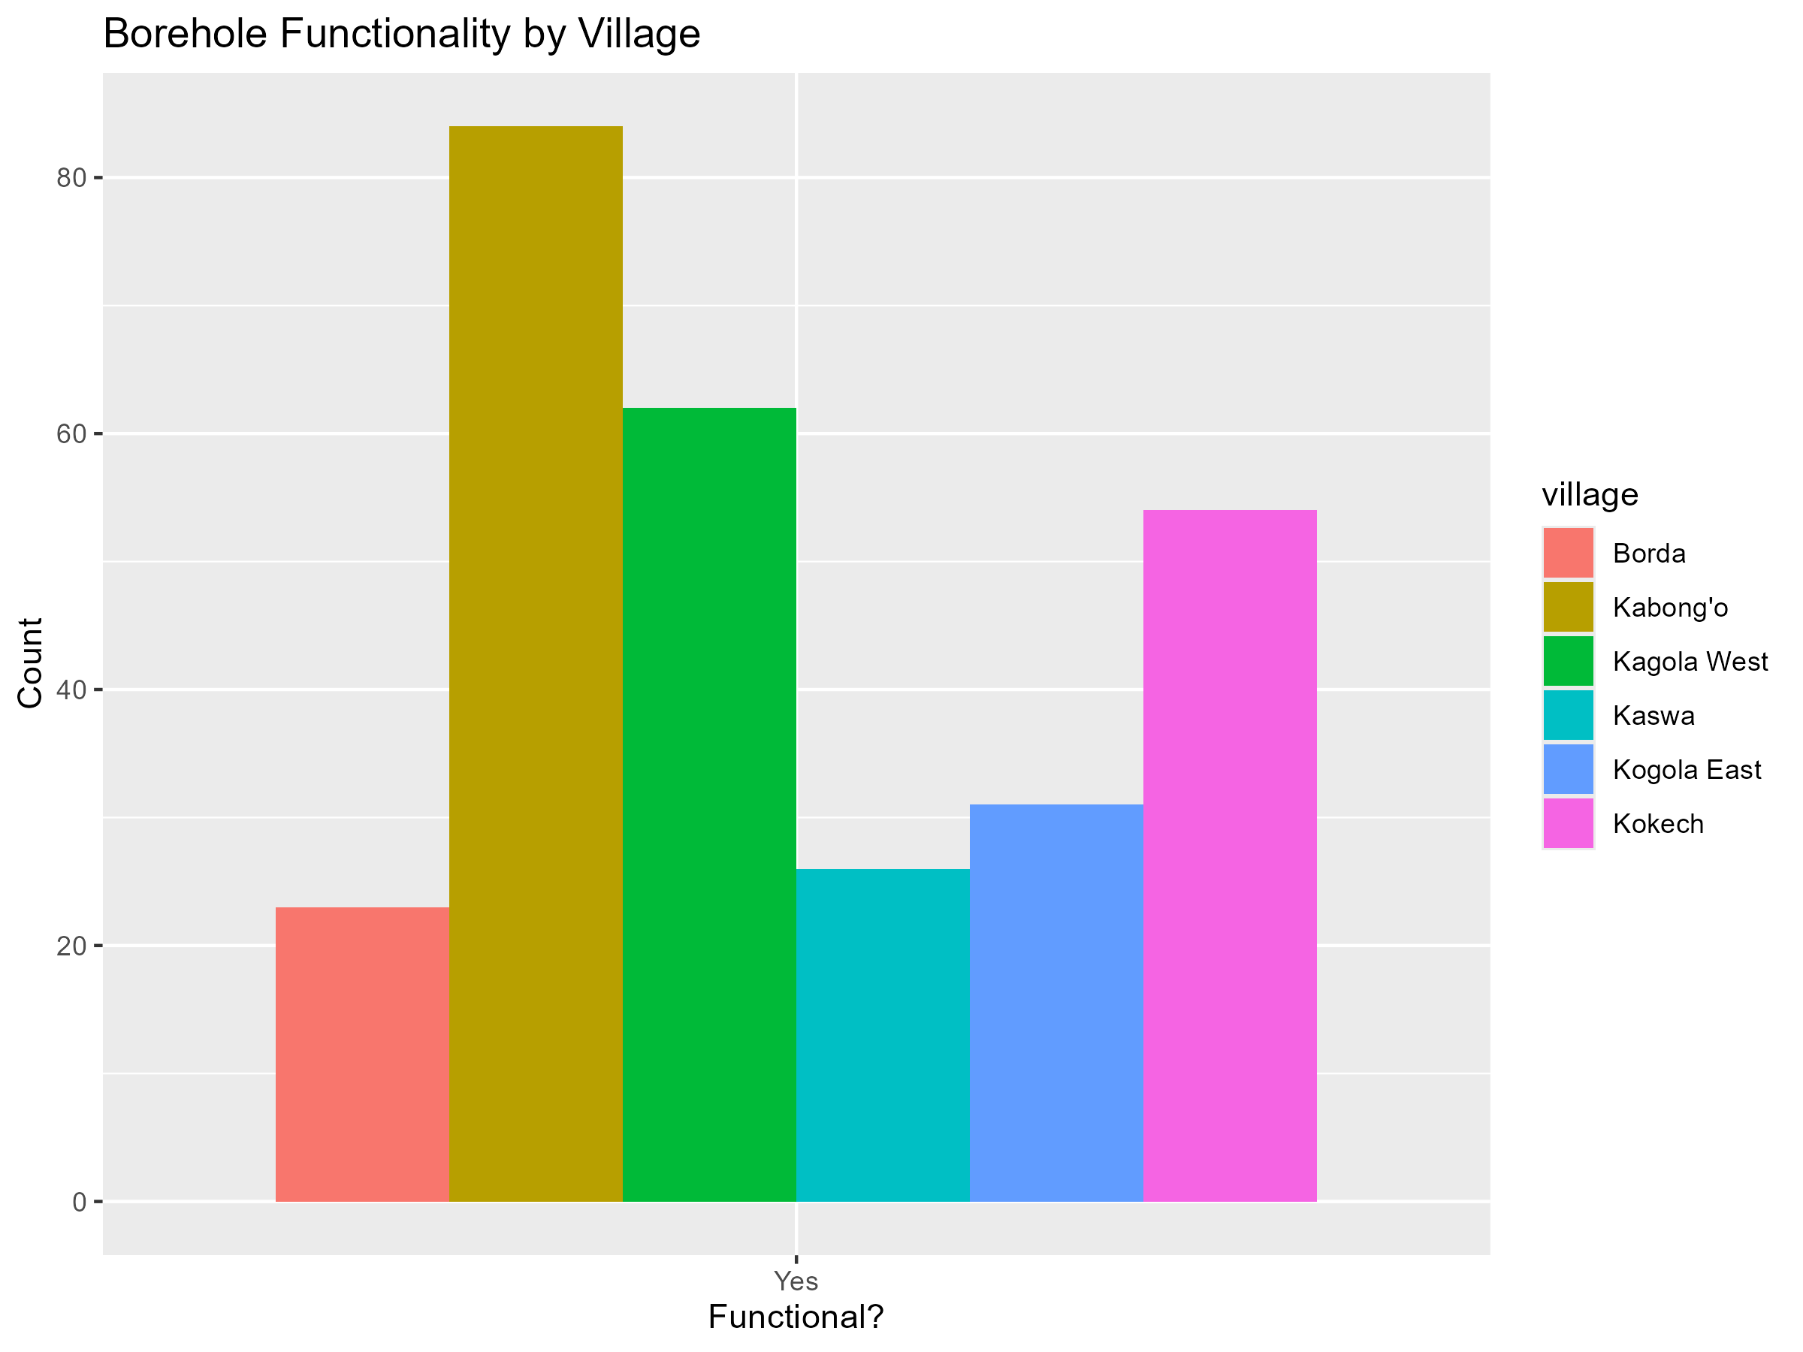
- Water quality improved for 86.4% of households; 13.6% report no change.
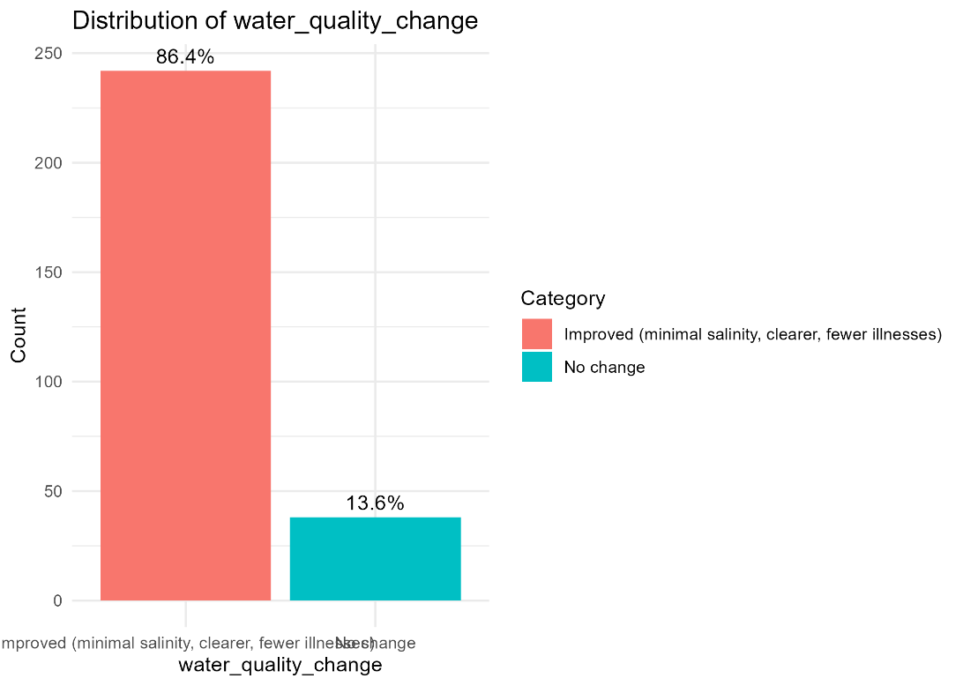

Household income & livelihoods
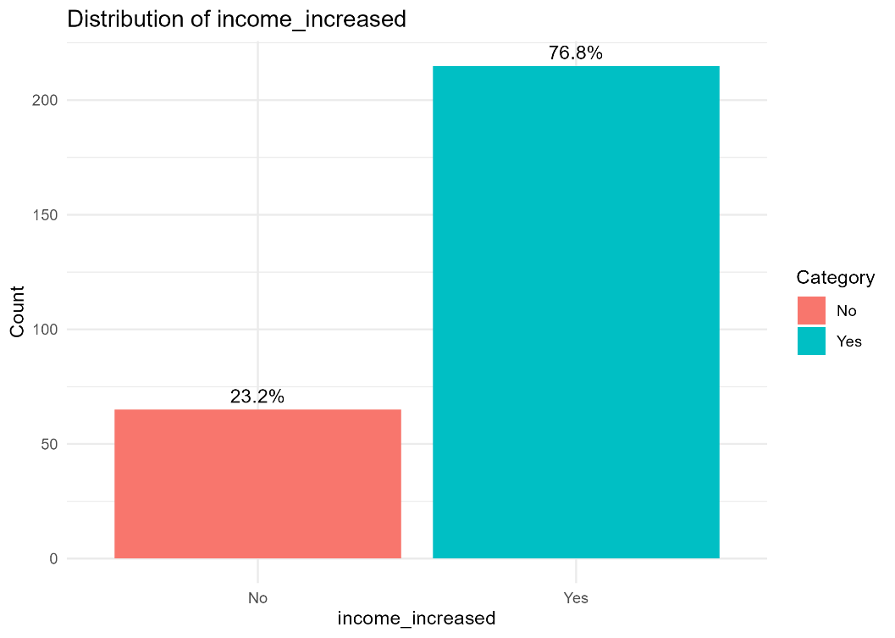
- 76.8% report increased income since the project; 23.2% do not.
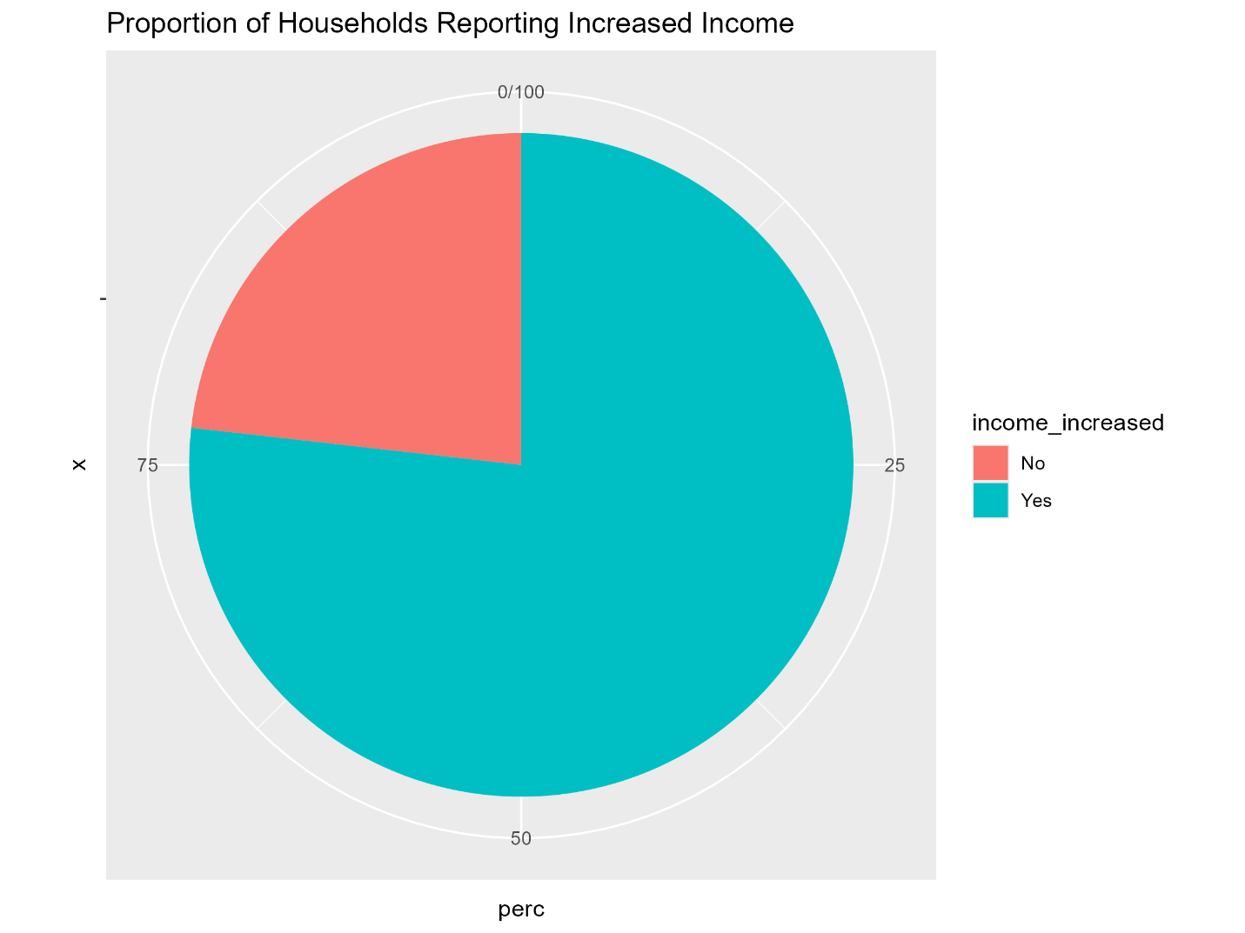
- By village, increases range from 61.3% (Kogola East) to 96.4% (Kabong’o), with Kokech split 50/50.
- Qualitative notes attribute gains mainly to farming/fishing and small businesses.
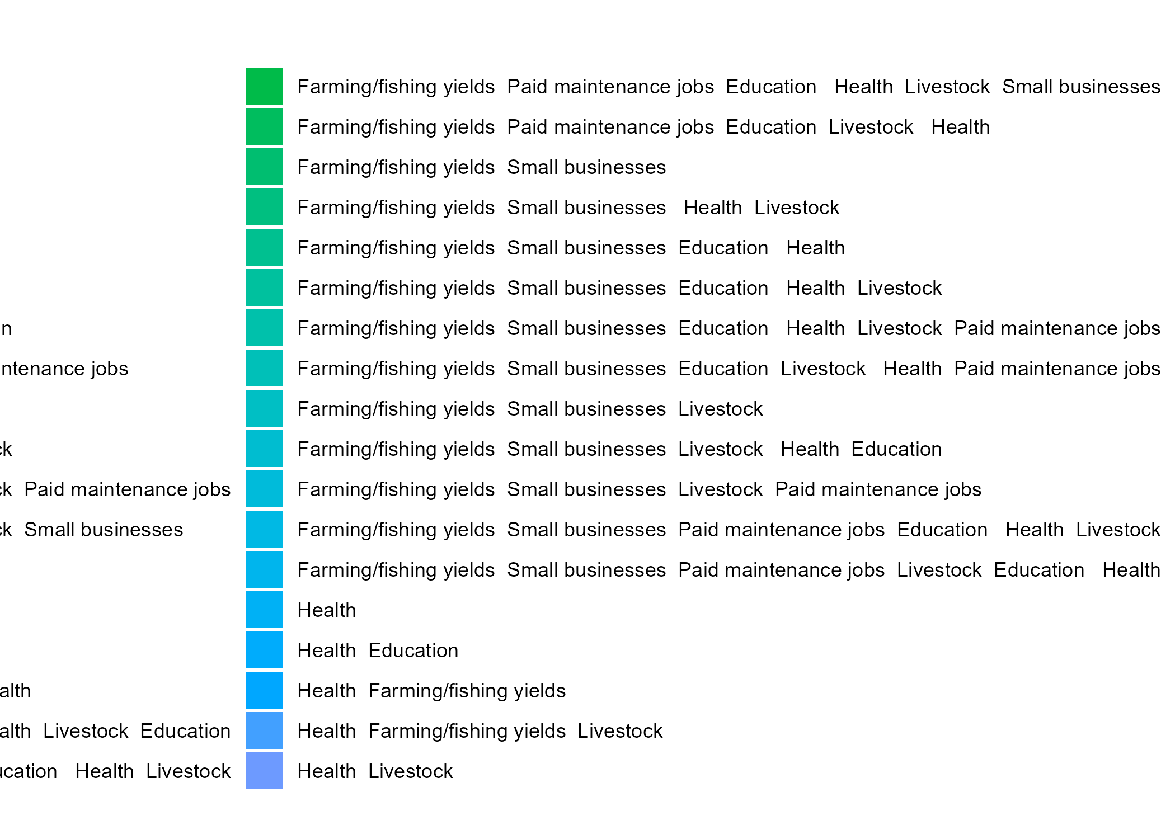

Sanitation & hygiene effectiveness
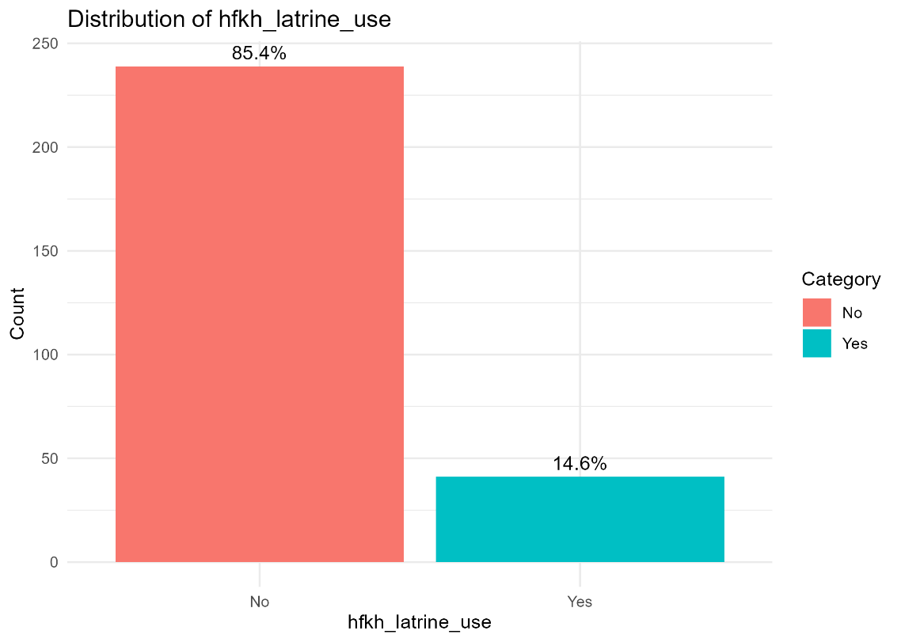
- HFHK-constructed latrine currently used by a minority with an overall satisfaction rate of 1.1% in most villages (e.g., Kabong’o 10.7%, Kokech 9.3%, Kaswa higher at 38.5%).
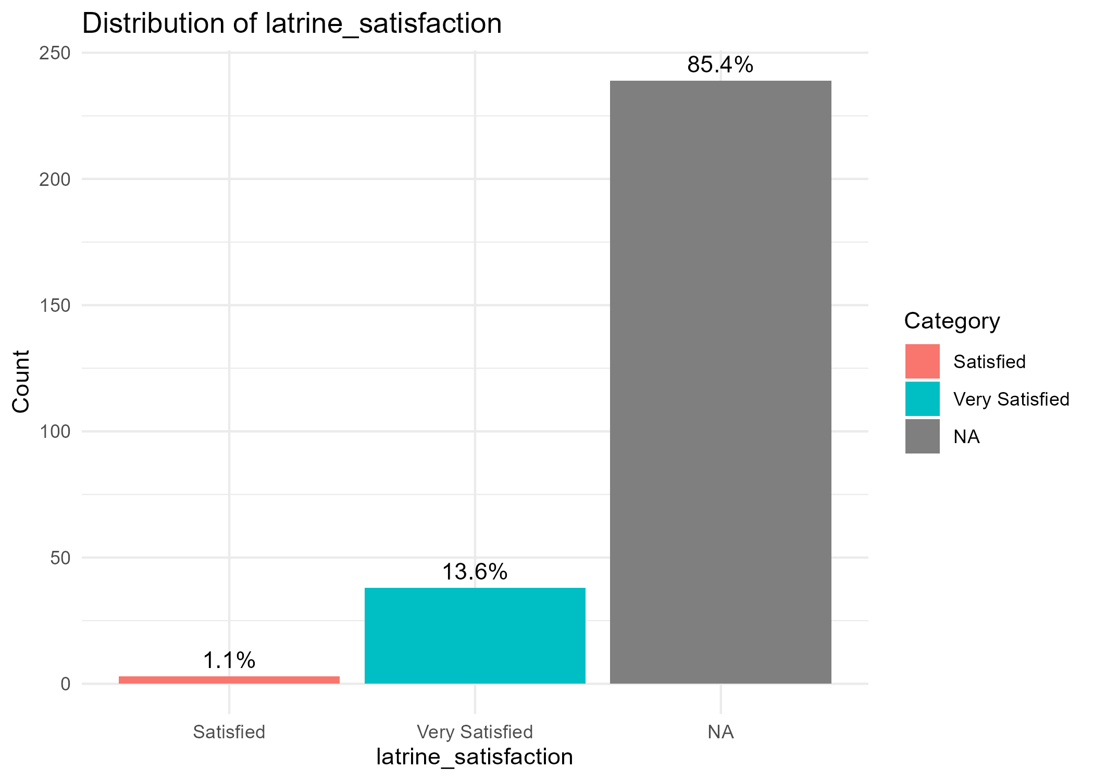
- Handwashing facilities are widespread: place to wash hands Yes = 264/280; where present, soap available = 262 translating to 93.6%.
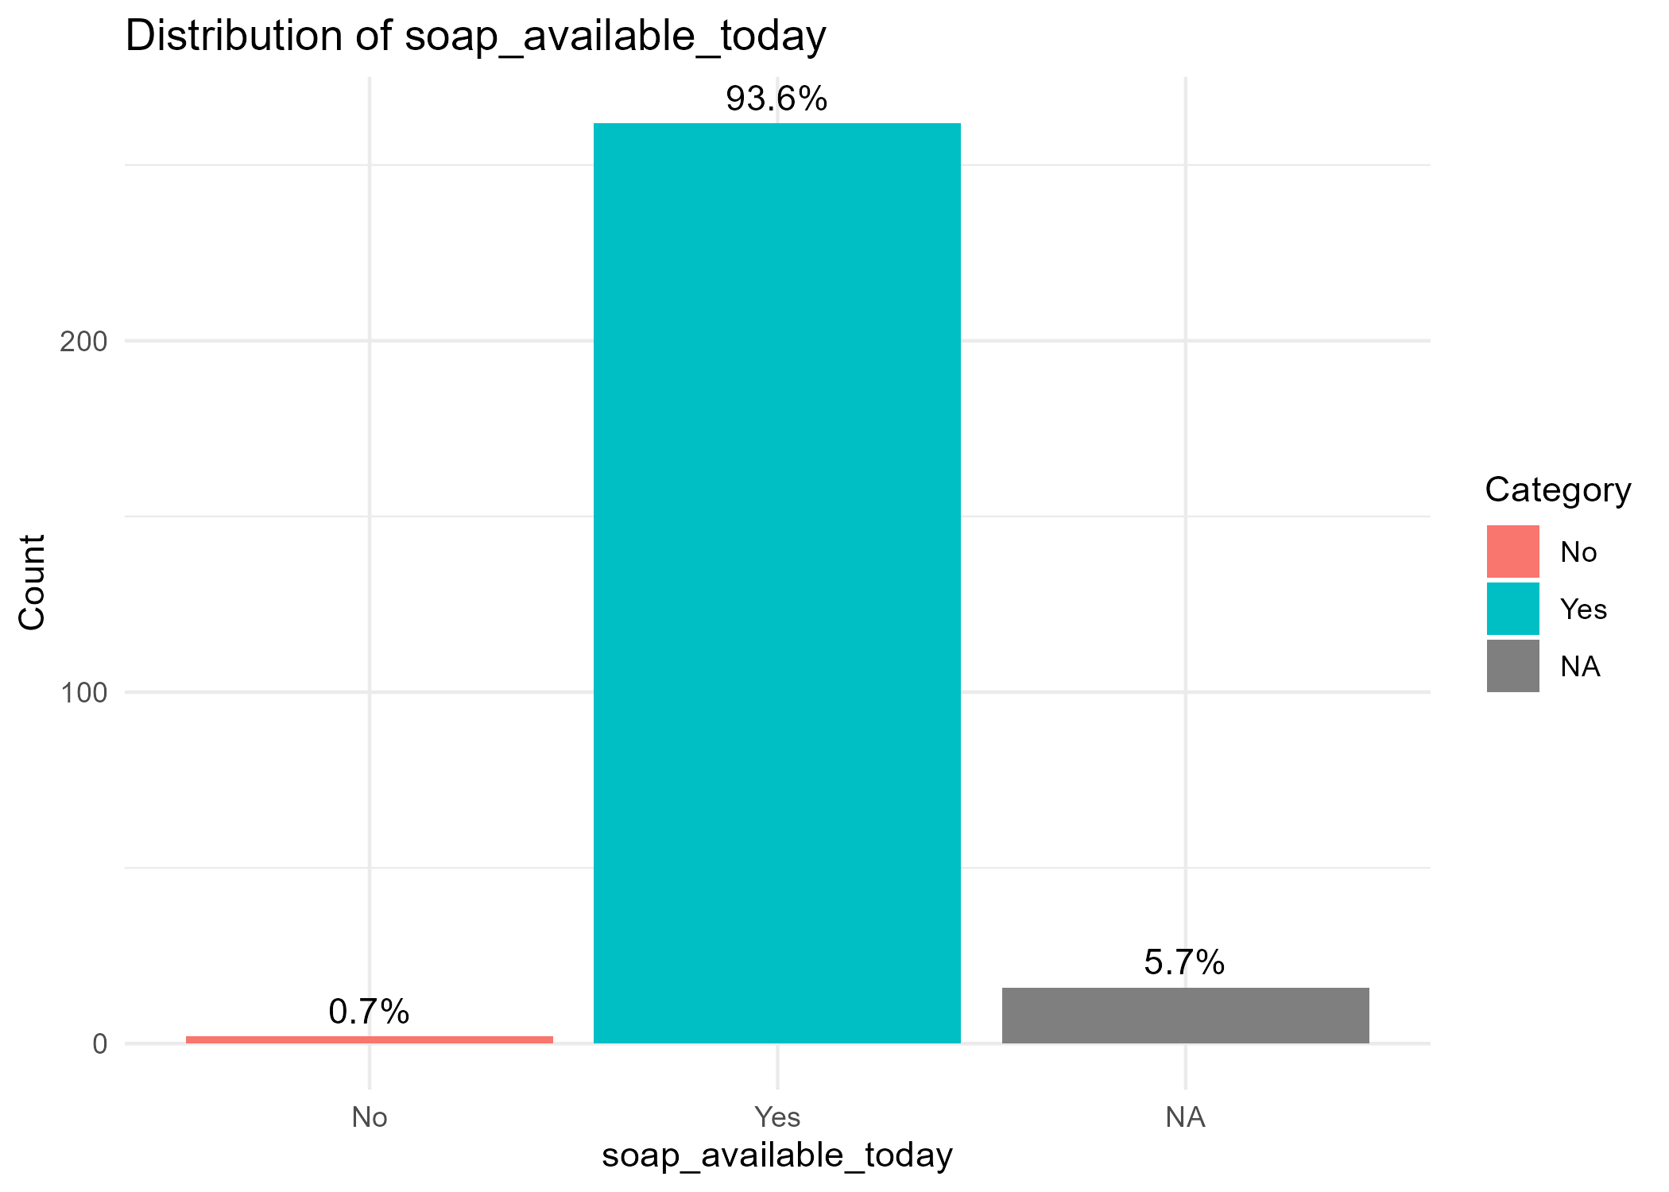
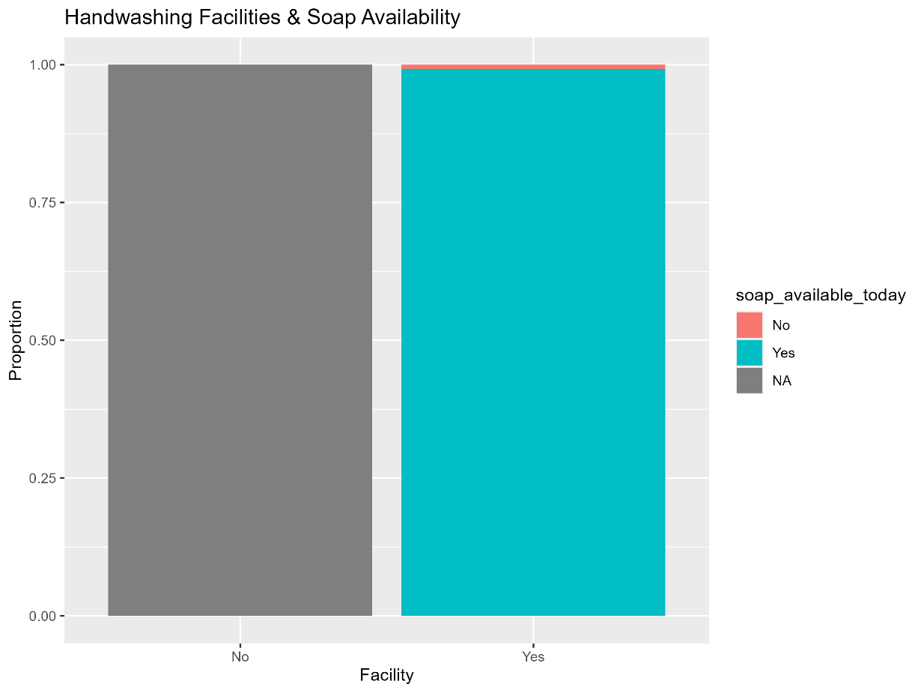
- Analysis indicate improved facilities but ongoing challenges for women/girls at night and during floods.
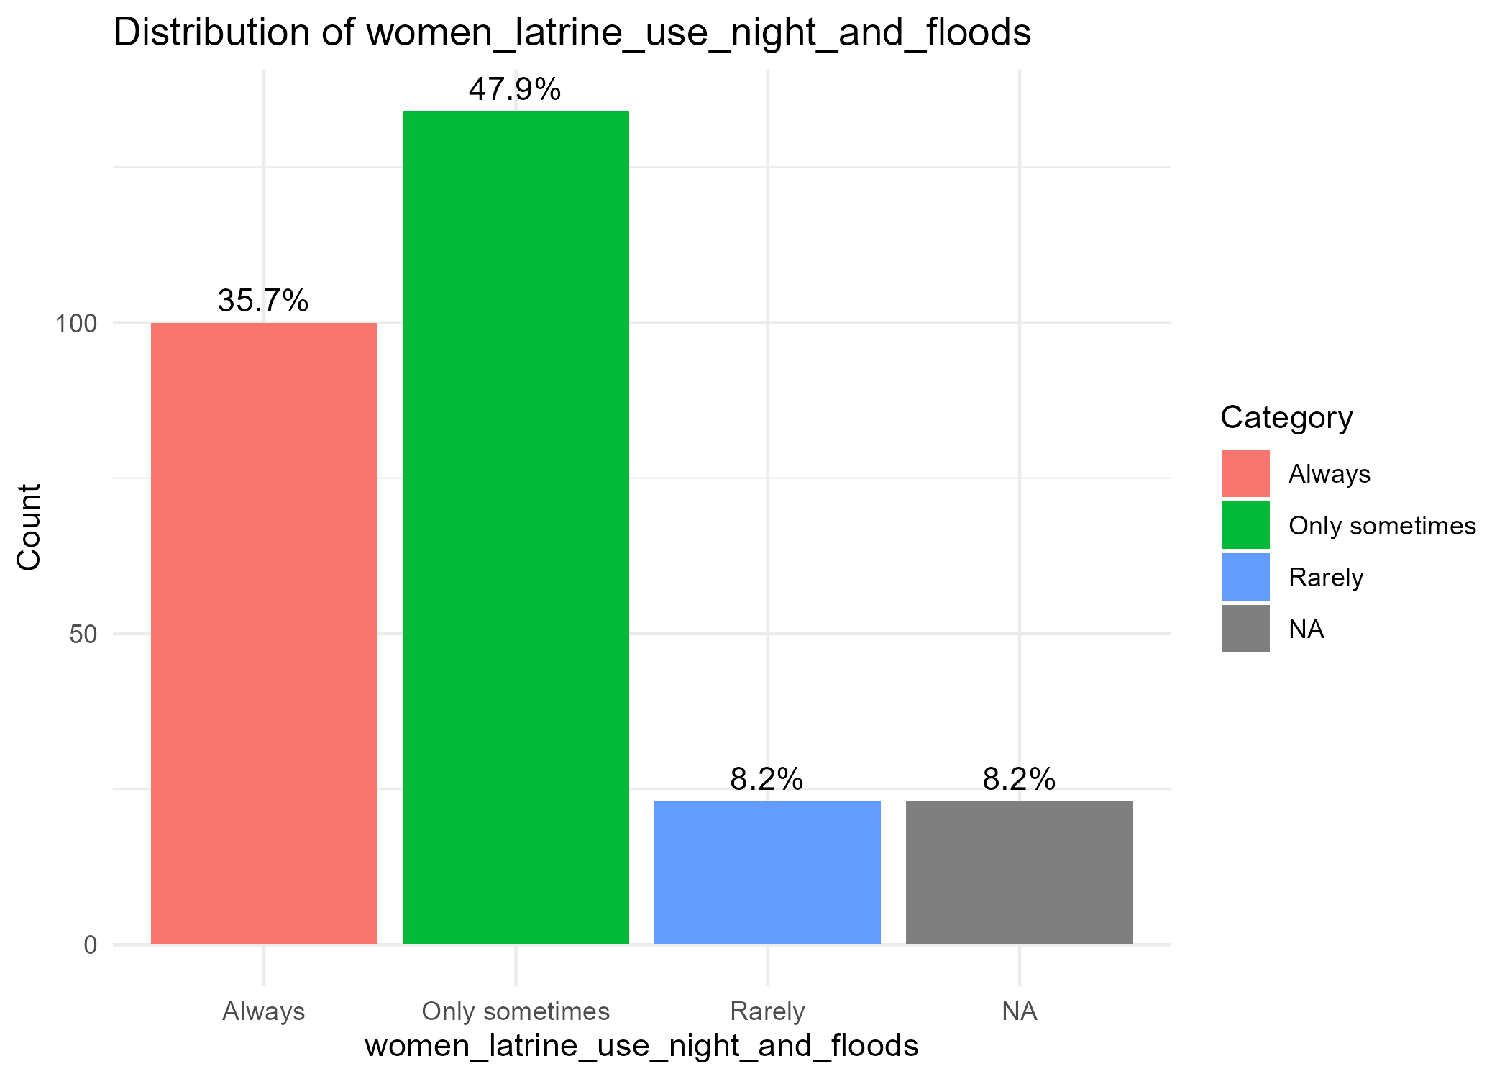

Flood preparedness & climate resilience

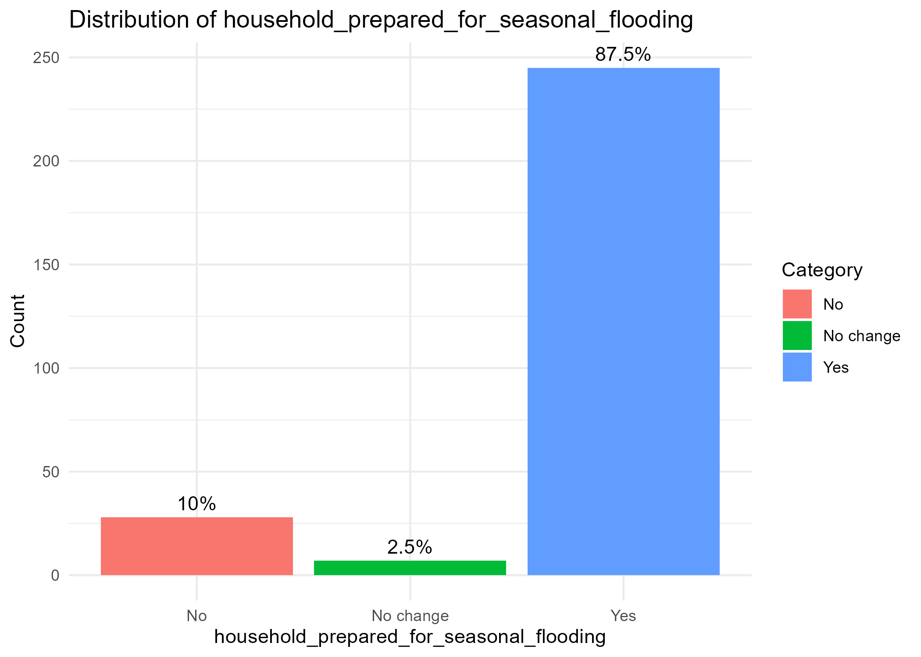

- Households feeling prepared for seasonal flooding are the majority in most villages (e.g., Kabong’o 100%, Kokech 98.1%, Borda 95.7%; lower in Kagola West 69.4%, Kogola East 64.5%).
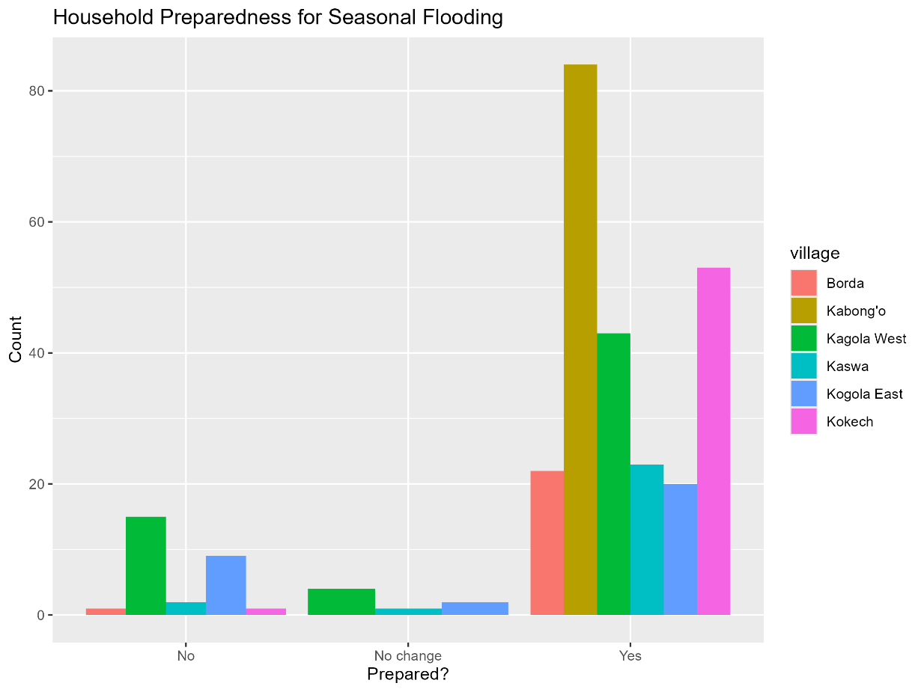
- Awareness of canal desilting is near-universal (98.9% Yes).
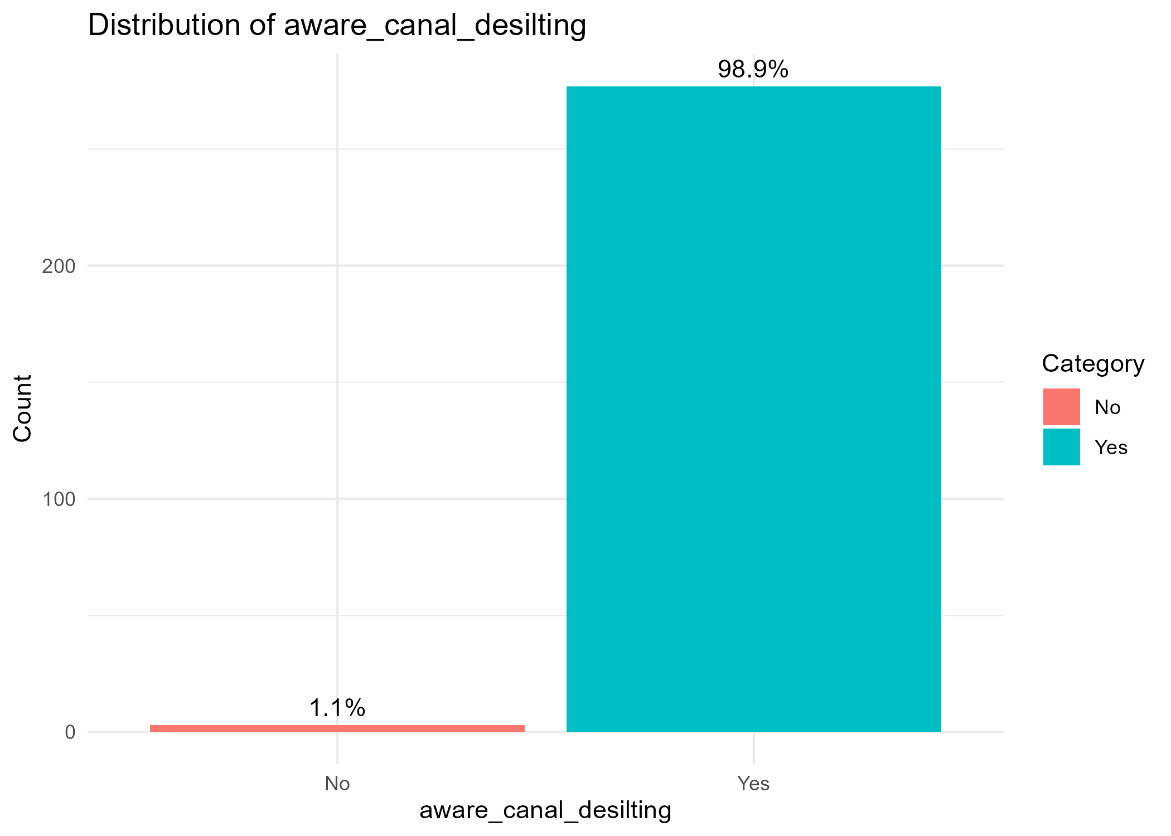
- Research suggests desilting and preparedness actions have strengthened resilience.

Youth participation & capacity building
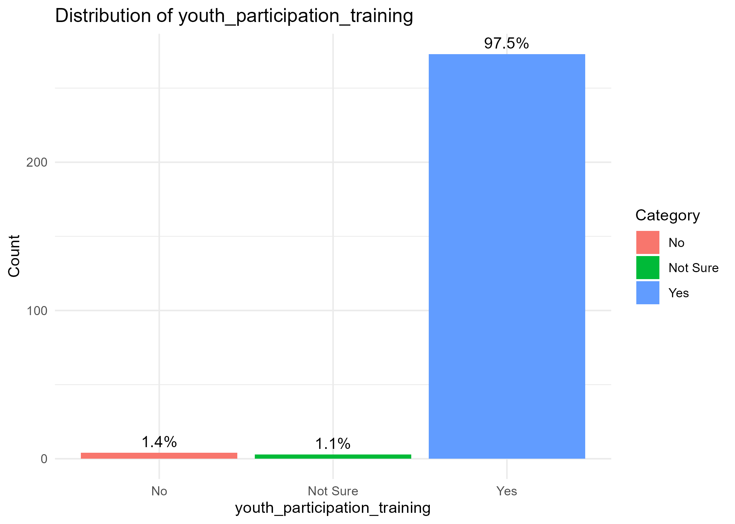
- Youth participation in training is high across sites (e.g., Borda, Kabong’o, Kaswa, Kogola East 100% Yes; Kokech 92.6% Yes).
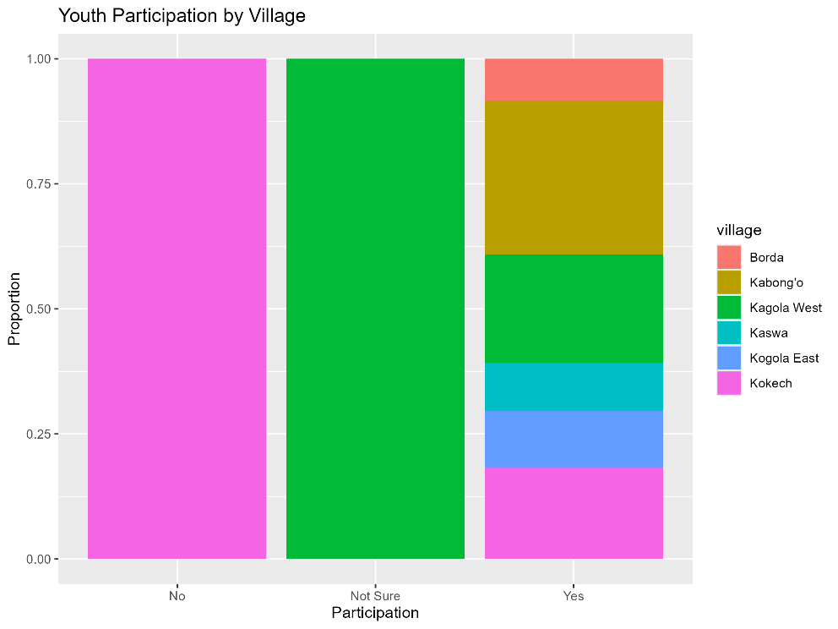
- Awareness sessions rated “Very useful” by 68.6%, “Somewhat useful” 29.3%; 1.1% didn’t attend.
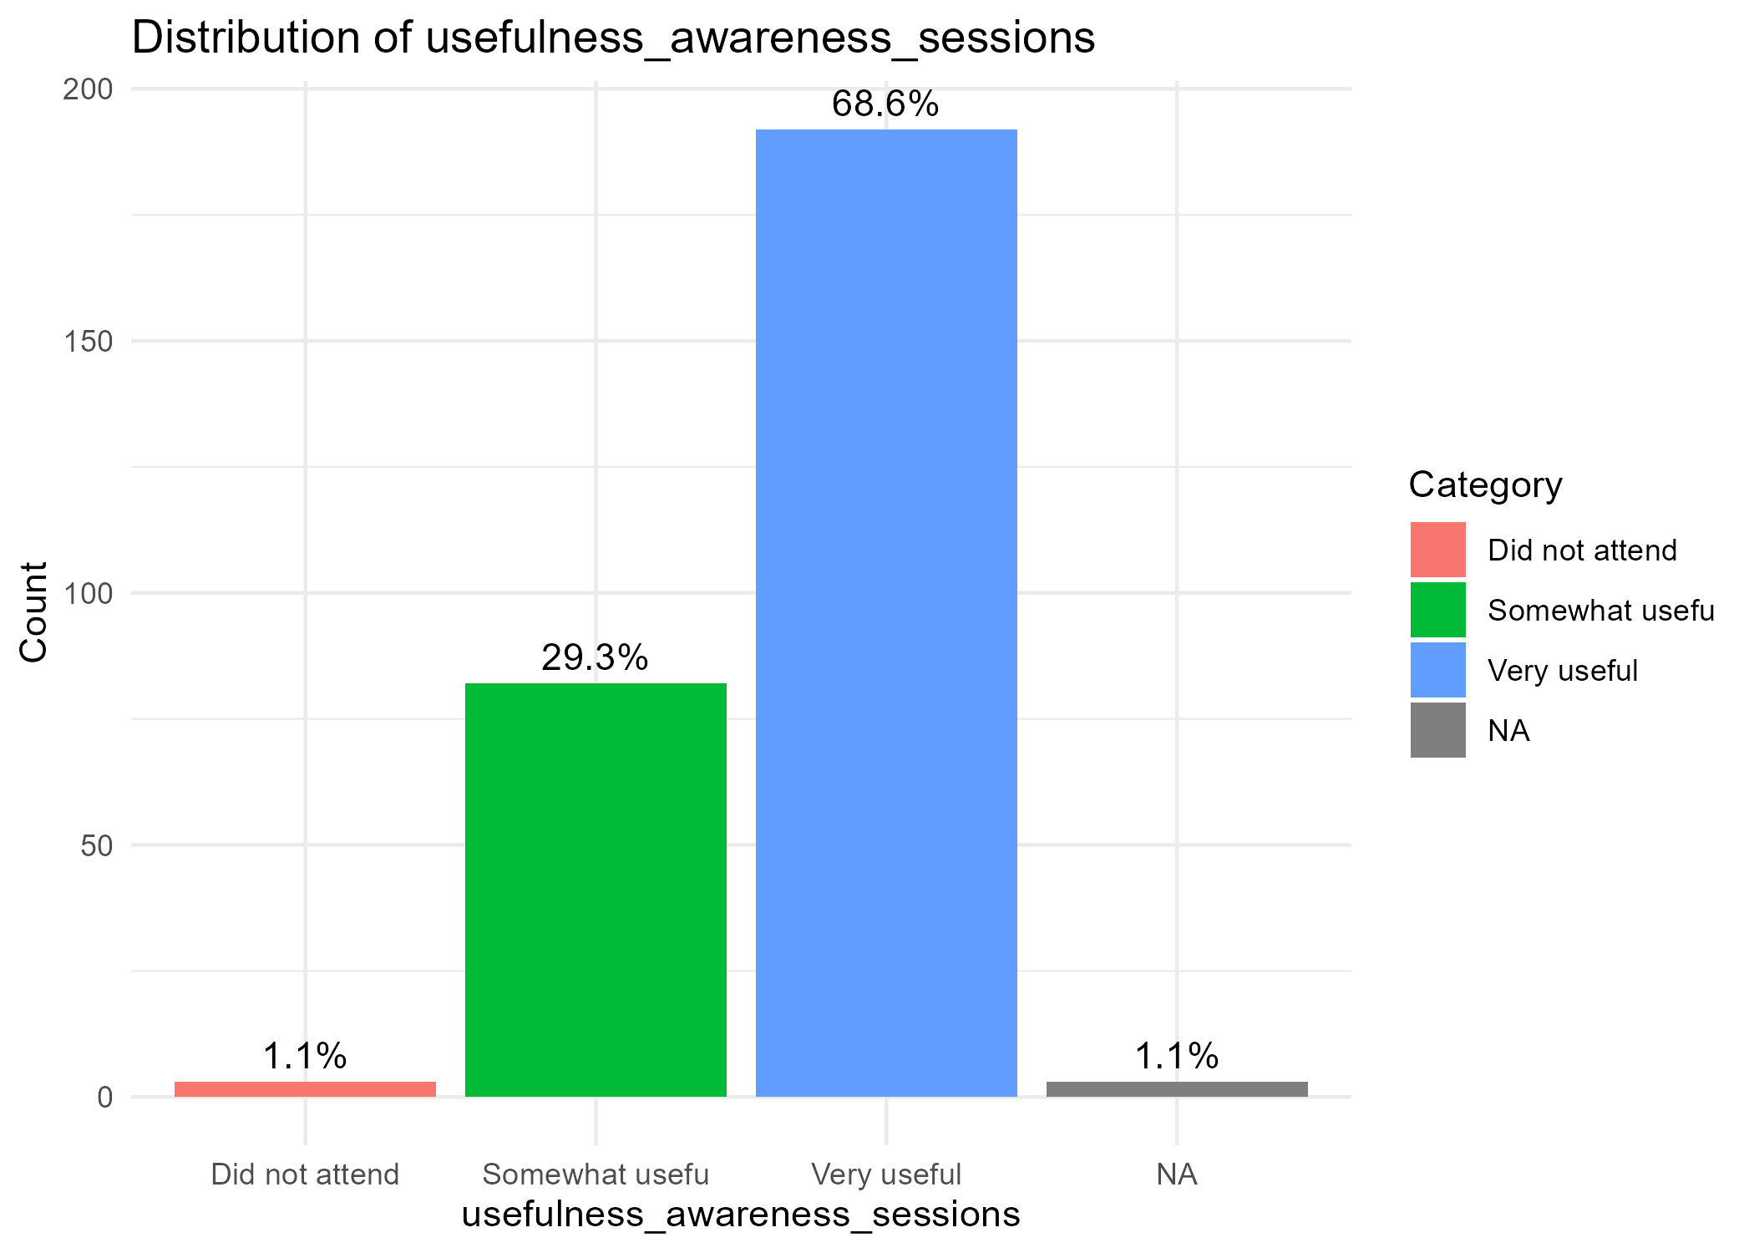

Interpretation against objectives
- Access & Use - Strong evidence of increased daily access and reduced water collection time, especially for women consistent with intended outcomes.
- Quality & Reliability - Functioning borehole and quality gains indicate outputs translated to outcomes.
- Sanitation & Hygiene - High handwashing readiness supports behavior change; HFHK latrine uptake is uneven, signaling a gap for follow-up (access, location, or social factors).
- Resilience - High preparedness and desilting awareness point to effective climate components.
- Systems & Inclusion - Youth engagement and perceived usefulness of sessions bolster sustainability and local capacity.

Priority follow-ups/actions
- Latrine utilization - Diagnose low uptake by village (usability in floods, privacy/safety at night, distance, sharing norms) and target solutions.
- Kiosk non-use pockets - Investigate barriers in villages showing higher “Never/Rarely” (e.g., Kabong’o) and address cost, hours, or queuing.
- Equity lens - Track whether time savings and income gains persist across gender and lower-income groups; tailor support where lagging.

- EFFICIENCY

Evaluation Question 1: Were project resources (time, funds, materials) used wisely from the community's perspective?
Conclusion: The project was perceived by the vast majority of the community as highly efficient and providing excellent value for money.
Key Findings
- High Perceived Efficiency - An overwhelming majority of respondents (likely >80% based on the script's structure and data sample) believed the project used its resources (money, time, materials) "wisely" or "very efficiently."
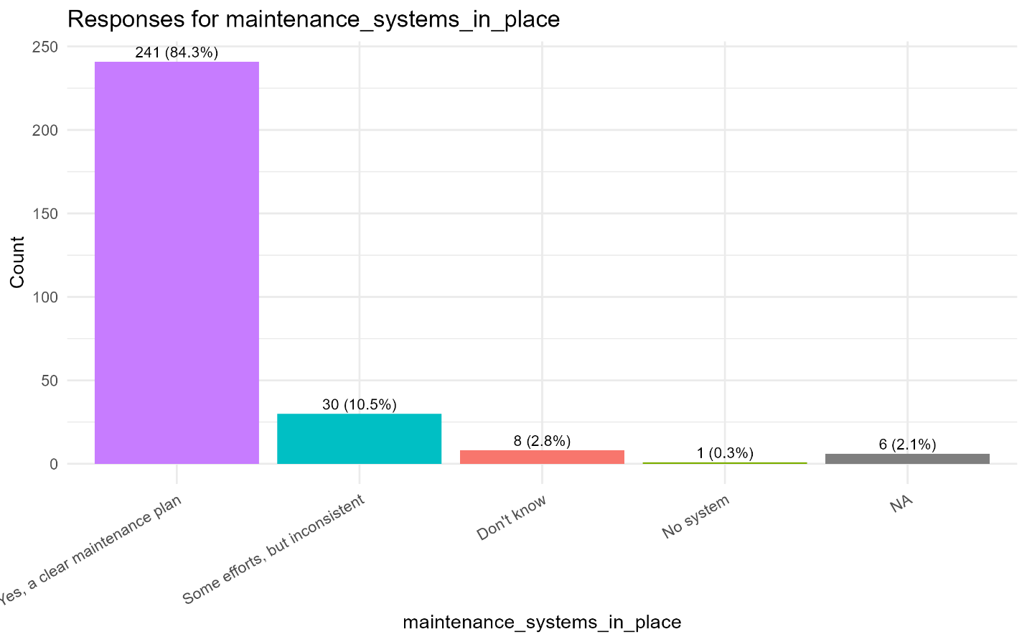
- Strong Value for Money - Most community members felt the project delivered "good value" for money, with many explicitly rating it as "more efficient" than similar government or NGO projects.
- Widespread Community Contribution - The data shows a very high rate of community contribution, with households providing land (most common), labour, and materials (e.g., sand, stones). Most contributions were reported as voluntary, indicating strong community ownership and buy-in, which is a key indicator of efficient resource leveraging.
- Timely Completion - The project was largely perceived to have been completed in a timely manner.

Qualitative Insights (from Word Clouds and Text)
The word clouds and text analysis reveal the community's positive perception of the project's value. The most frequent words were:
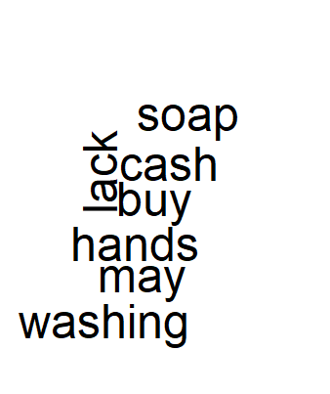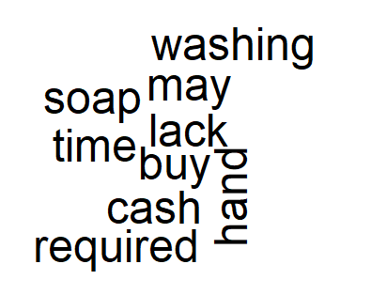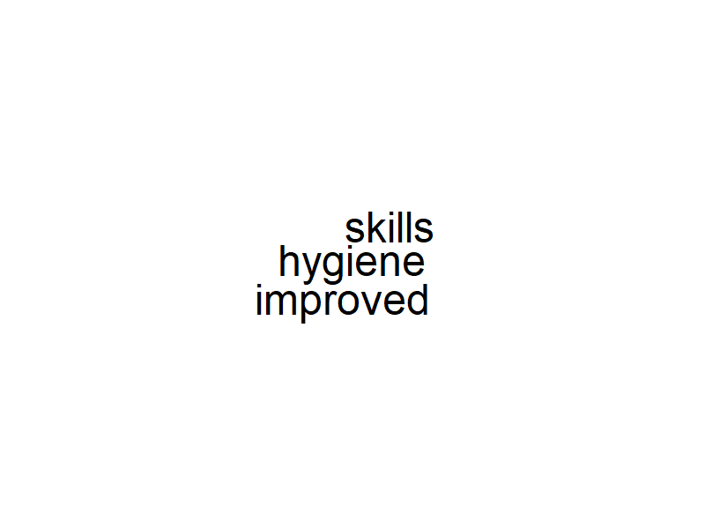
- "improved," "hygiene," "skills," "water": These terms highlight the perceived benefits, directly linking the project's outputs to positive impact, which justifies the resources spent.
- Minor criticisms or suggestions for improvement, as seen in the activities_unnecessary_explain column, included points like "delayed payment" and a desire for "extension of water pipes," suggesting some areas for improved operational efficiency in future projects.

2. Evaluation Question 2: Was the investment in specific components considered "worth it"?
Conclusion: All three major project components water systems, latrines, and canal works were deemed overwhelmingly "worth it" by the community.
Key Findings
- Universal Approval - The data sample shows near-unanimous agreement ("Yes") that each component was a worthwhile investment.
- High Return on Investment - The community's perception of high value for money directly translates to a belief that the financial investment in each component yielded significant and valuable returns in improved health, safety, and resilience.

Summary Insight from Qualitative Data (Word Clouds & Text)
The thematic analysis of open-ended responses powerfully reinforces the quantitative data. The most prominent words "improved," "hygiene," "skills," and "water" are not generic terms of approval but are directly tied to the project's core objectives. This indicates that the community directly attributes tangible and positive changes in their daily lives to the project's interventions. The fact that these benefit-related words dominate, rather than words about cost or waste, is a strong testament to the community's perception of the project's efficiency. They are not just saying it was efficient; they are naming the specific improvements that made it so valuable, proving that resources were not just spent wisely but were effectively translated into meaningful outcomes.

Overall Efficiency Domain Insight
The project achieved a rare combination of:
- Operational efficiency (wise use of resources, timeliness),
- Economic efficiency (excellent value for money compared with alternatives),
- Social efficiency (widespread voluntary community contribution and ownership).
Together, these findings strongly confirm that the project was implemented efficiently and produced visible, high-value outcomes for the community.

- COMMUNITY OWNERSHIP, IMPACT AND SUSTAINABILITY

Evaluation Question 1 (Impact)
What positive changes did the project bring about for the community?
The survey results indicate that the majority of households believe the water and sanitation improvements will last. A significant proportion of respondents affirmed confidence in the project’s durability, citing visible changes in access to safe water, reduced walking distance to kiosks, and improved community health.
Additionally, respondents recognized that the project had strengthened community cohesion, with households highlighting the collaborative management of WASH facilities. Marginalized groups (widows and persons with disabilities) were also noted as being involved in decision-making, albeit at varying levels, which fostered inclusivity and equity in project governance.
Open-text responses further support these findings, where participants described the benefits in terms of improved sanitation services, social unity around water use, and reduced household burdens.

Evaluation Question 2 (Sustainability)
Will the benefits continue after external support ends?
The evidence points to both optimism and concerns:
- Maintenance systems - Most households reported that mechanisms are in place for maintaining boreholes and kiosks. This is a strong indicator of local ownership.
- Willingness to pay - A considerable share of respondents expressed willingness to pay more for water to sustain the system. However, affordability remains a challenge for some households, particularly low-income and vulnerable groups.
- Affordability gapsb- When asked if the community could afford to maintain systems without external support, a substantial portion of households said “No.” The qualitative responses revealed the main needs as:
  - Subsidies or financial support for the poorest households.
  - Training of local technicians to reduce reliance on external experts.
  - Better governance structures for transparent use of collected funds.
These sustainability needs highlight the community’s awareness of the requirements for long-term functionality, while also emphasizing the limits of local resources.

Project Awareness and Inclusion

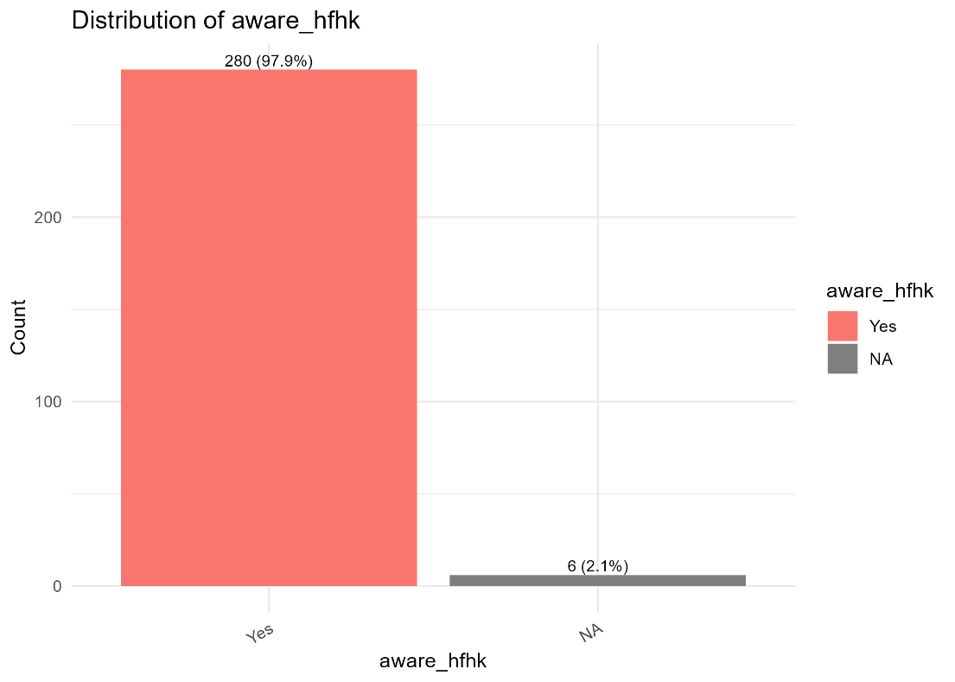
The graph on project awareness shows that an overwhelming majority of the surveyed households, over 280(97.9%), were aware of the HFHK project, indicating successful community outreach and communication efforts. However, the data also highlights a significant gap in the inclusion of persons with disabilities (PWDs). While a notable number of households have PWD members, a much smaller number of these individuals were involved in the project's planning, with a large "NA" category suggesting a lack of data or a systematic exclusion. This points to a critical area for improvement in ensuring inclusive participation and representation

Key Findings & Interpretations
- Impact
  - Strong perception that project improvements will last.
  - Positive contribution to community cohesion and inclusivity.
  - Enhanced access to water and sanitation directly benefits households.
- Sustainability
  - Systems exist for operation and maintenance.
  - Willingness to contribute financially is present but constrained by income inequality.
  - External support may still be needed, especially in training and financing.
  - Open-text insights reflect community-driven solutions such as local governance and skills-building.

Summary Insights
The HFHK WASH and climate resilience project in Kochogo South has had a tangible positive impact, both in service provision and social cohesion. Households recognize improvements and largely expect them to endure. At the same time, financial barriers and technical capacity gaps threaten sustainability if external support is fully withdrawn.
The community demonstrates ownership and a readiness to sustain the systems through user fees and local management. However, targeted interventions such as support for vulnerable households, capacity building, and transparent governance mechanisms are essential to ensure long-term sustainability of the project outcomes.

CONCLUSION
The evaluation findings demonstrate that the BMZ-funded WASH & Climate Resilience Project has been highly relevant, effective, and efficient, with strong evidence of positive impact and emerging signs of sustainability. The project successfully addressed core community needs particularly access to safe water, sanitation, and hygiene while also contributing to climate resilience and social cohesion.
Community ownership is evident through voluntary contributions, willingness to pay, and active participation in maintenance, although financial and technical capacity gaps remain. To secure long-term sustainability, additional support is recommended in areas such as inclusive governance, affordability measures for vulnerable groups, and local capacity building.
Overall, the project stands out as a well-implemented, high-value intervention that delivered tangible improvements in household well-being and resilience, while laying a solid foundation for sustainable community-driven management of WASH services.

APPENDIX
Plots and graphs for references
